RESUME

ALUGU SRIVANI 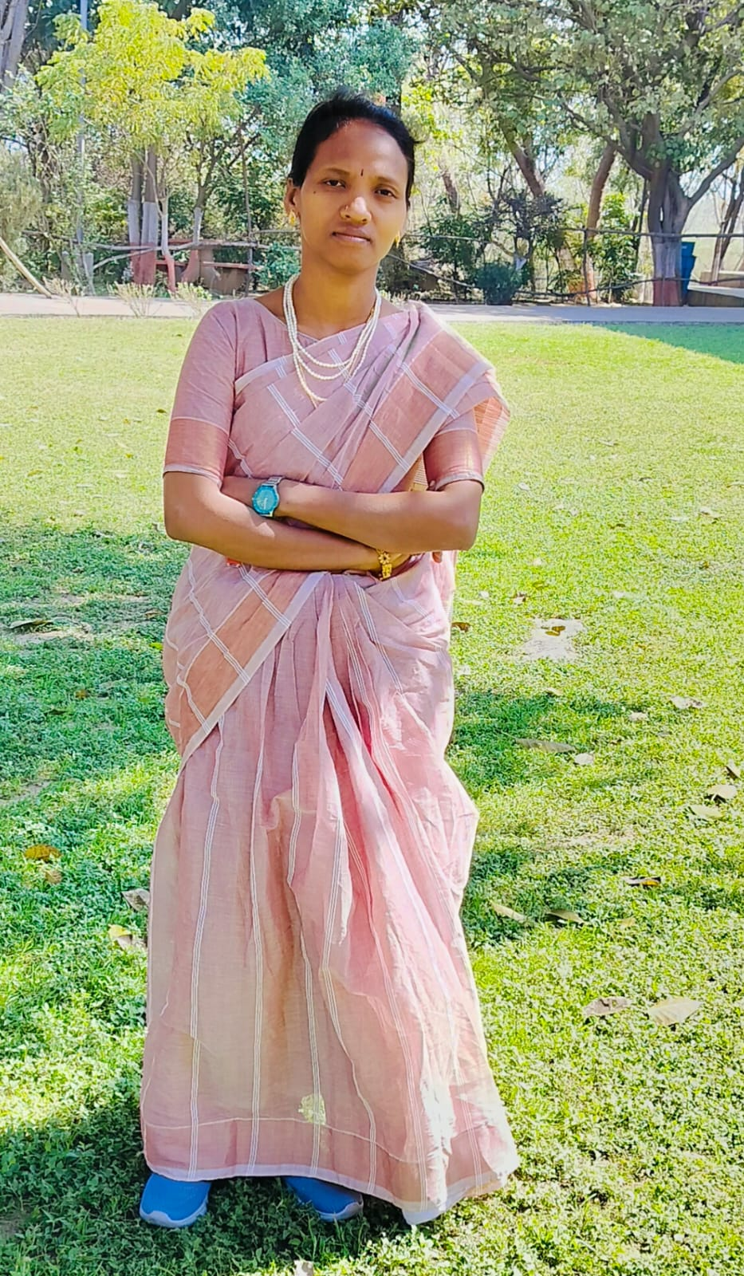
S/O CHANDRARASEKHARA RAO
VATHADA VILLAGE
KONDAVADA POST,
GUMMLAXMIPURAM MANDAL,
VIZIANAGARAM DIST, ANDHRA PRADESH
PINCODE: 535523 CELL NO: 9493554966
Mailed: alugu.srivani08@gmail.com

CAREER OBJECTIVE:

To get growth oriented position in an organization where my analytical skills can be utilized for improvement and success of the organization and to improve my knowledge through learning.

EDUCATIONAL QUALIFICATION

- MA HISTORY Andhra University, Visakhapatnam

- B.Ed Chanakya College of Education Vizianagaram,

- DEGREE (HEP) Arts background (HISTORY, ECONOMICS, POLITICAL SCIENCES ) from Government Degree college, Gummalakshmipuram

- Intermediate (M.P.C) from A.P.T.W.R (G) Junior college, Bhadragiri, Gummlakshmipuram, Vizianagaram

- SSC from G.T.W.H School, Regidi, Gummlakshmipuram, Vizianagaram.

PERSONAL APPRAISAL
- Good communication skills

- Ability to grasp and learn new technology quickly & accurately.

- Very enthusiastic and highly motivated with a positive attitude.

- Flexibility &Adaptability

CORE COMPETENCIES

- Punctuality

- Positive attitude

- Dedication , commitment and accountability

HOBBIES:

- Reading books
-
PERSONAL DETAILS
Name : A. SRIVANI

Father Name : A. CHANDRARASEKHARA RAO

DOB : 08-07-1991

Sex : Female

Cast : ST

Marital Status : Unmarried

Nationality : Indian

Language Known : Telugu, English

Communication Address: S/O Chandrasekhar Rao
VATHADA VILLAGE
KONDAVADA POST,
GUMMLAXMIPURAM MANDAL,
VIZIANAGARAM DIST, ANDHRA PRADESH
PINCODE: 535523

DECLARATION

I hereby declare that the given information provided by me is true and correct to the best of knowledge and belief.
Date: Gummalakshmipuram
Place: Signature

- SRIVANI)

